SINGLE NODE CLUSTER OPENSHIFT DEPLOYMENT

1. Create a VM RHEL9 in VMWare Workstation with Configuration of 4GB/60GB HDD/4vCPU
2. Add Network Adapter-NAT

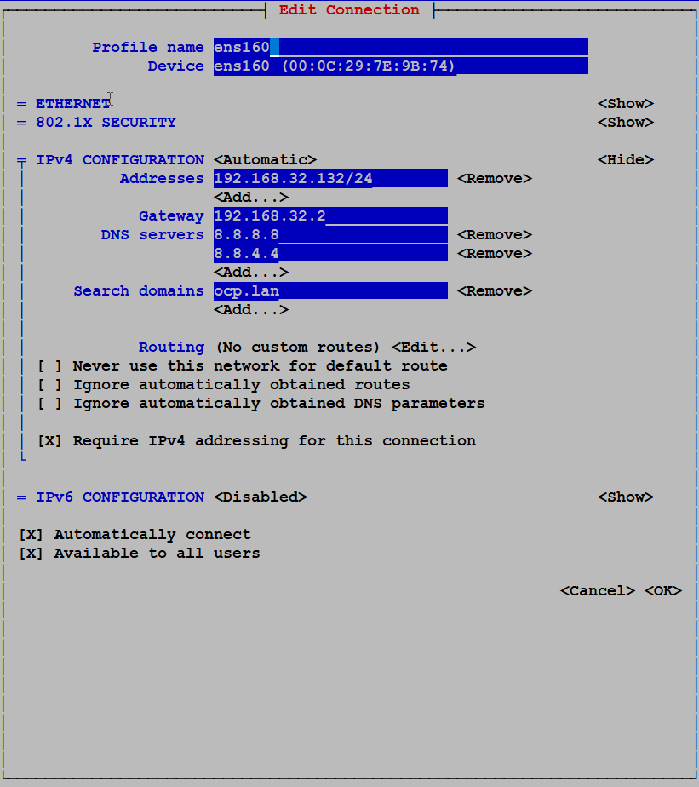

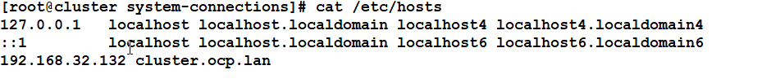

3. create a public key ssh-gen

[root@cluster ~]# cat .ssh/id_rsa.pub

ssh-rsa  [root@cluster.ocp.lan](mailto:root@cluster.ocp.lan)

**VM created with its named-Cluster**

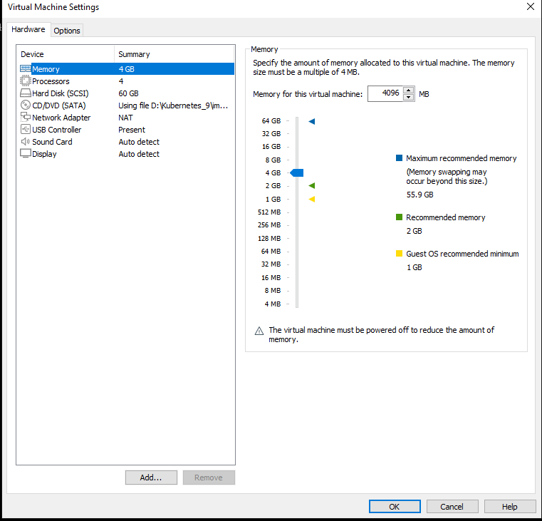



1.Open OpenShift console:

<https://console.redhat.com/openshift/overview>

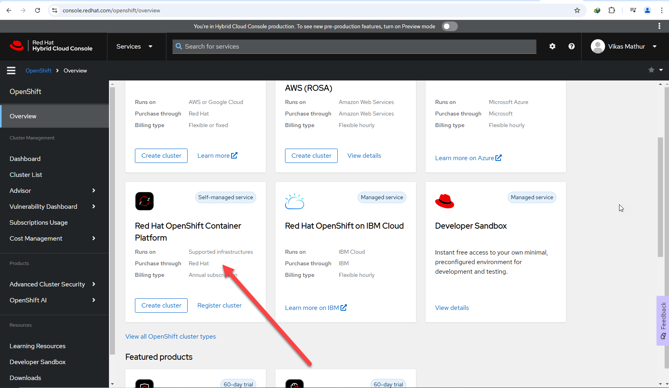

2. 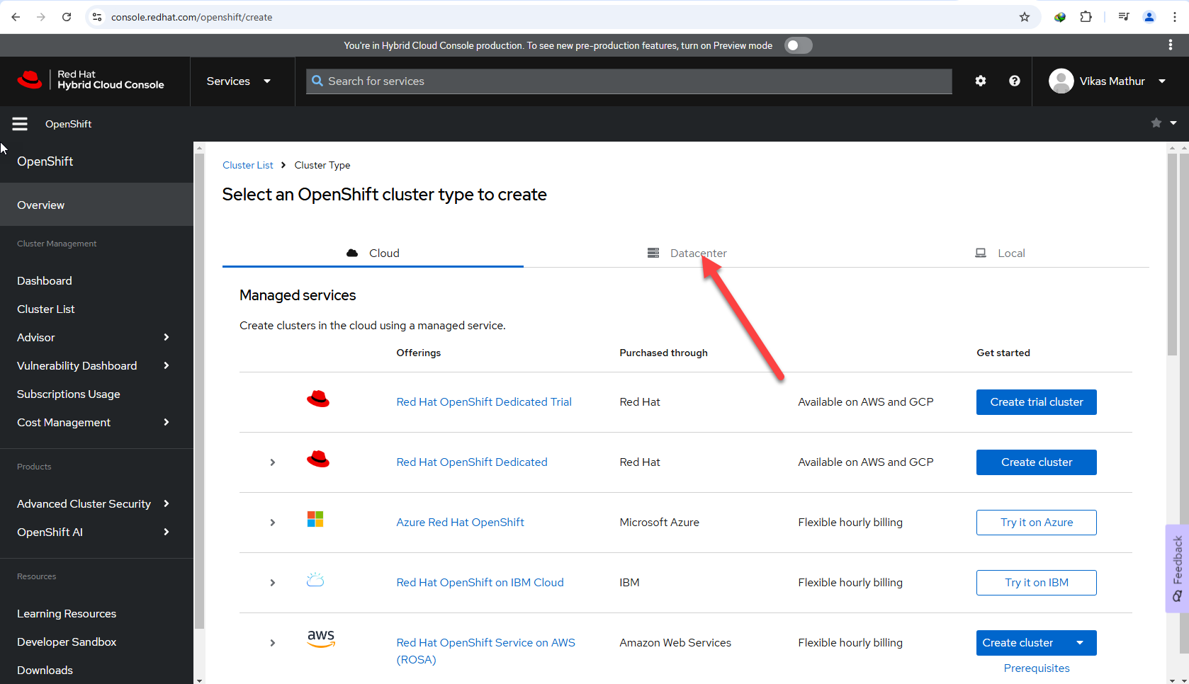

3.Click it Assisted Installer

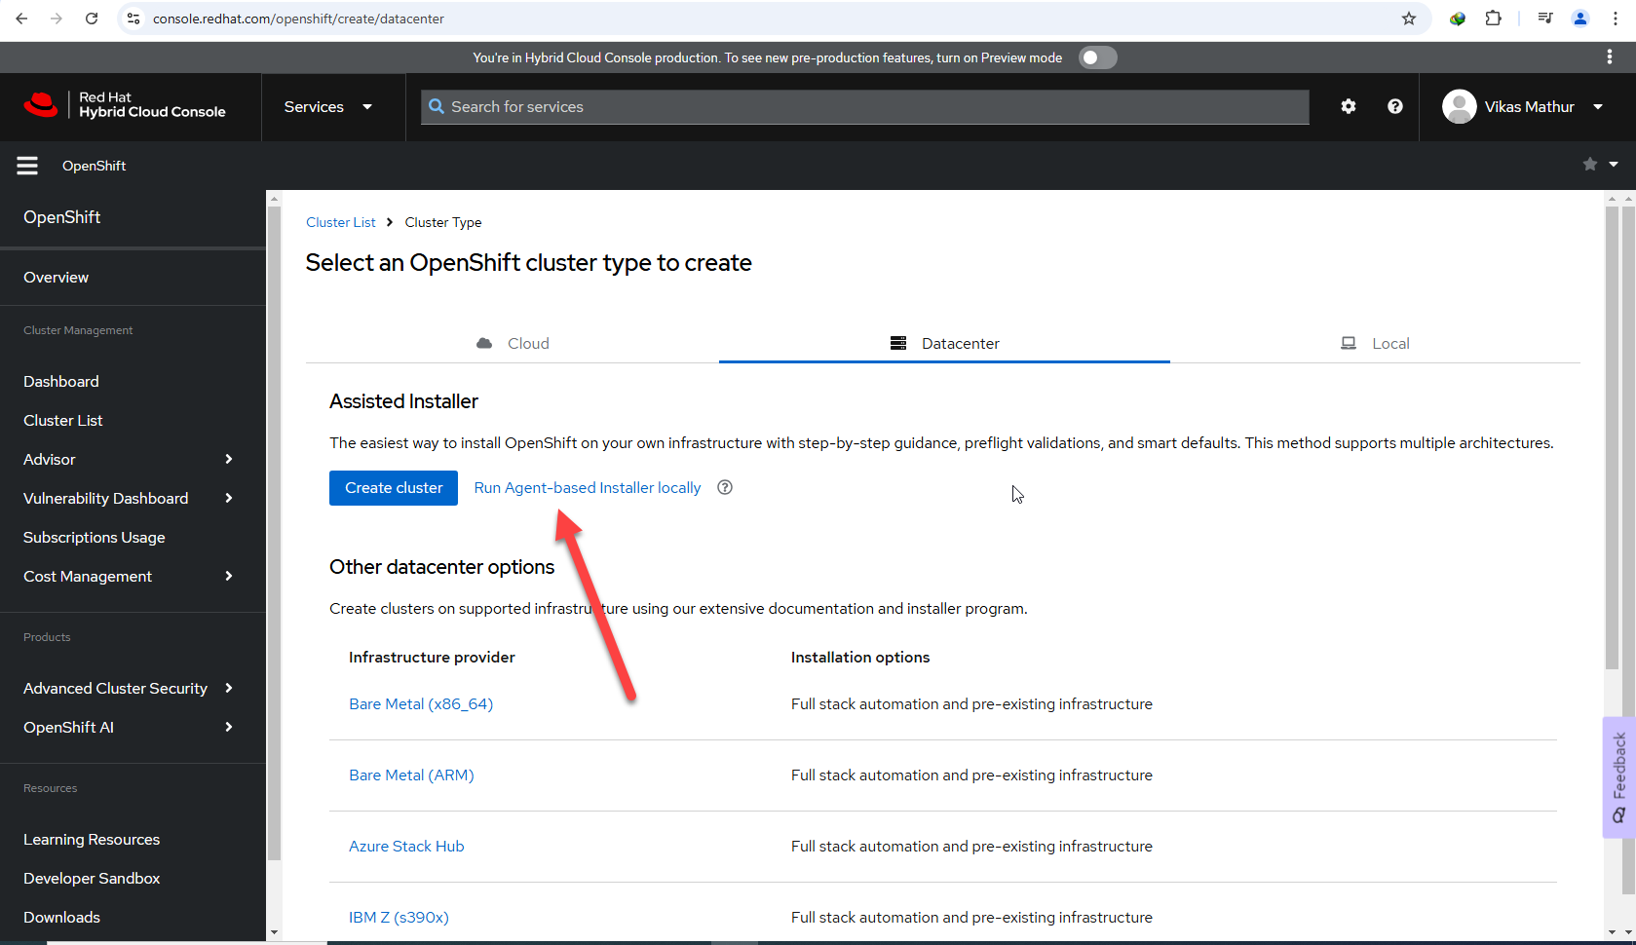

1. Fill the cluster value

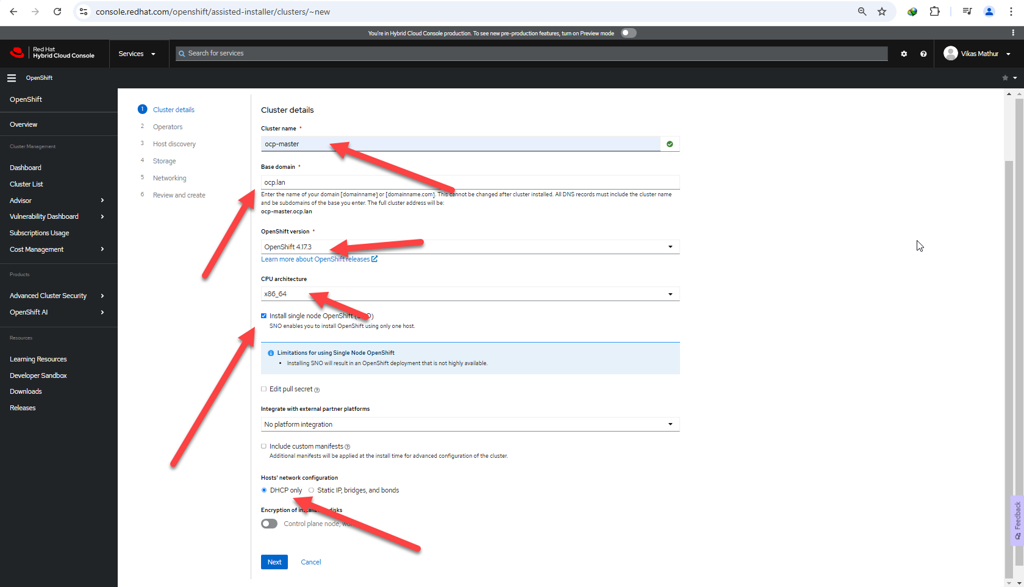

4.click it next

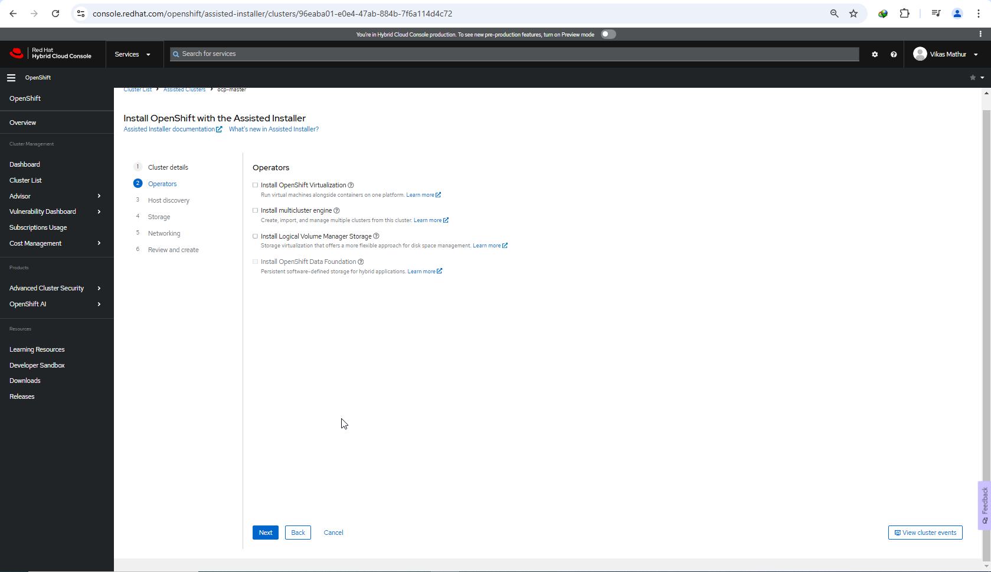

5.Add host and choose full image with placed the public key and download that iso file.

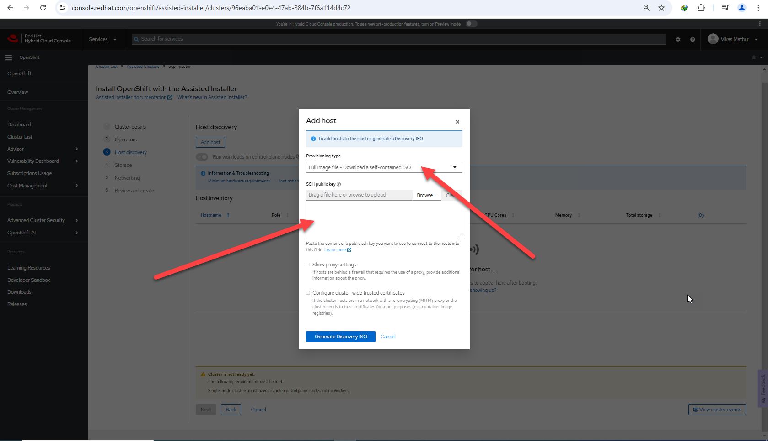

**6. Now create a VM with 49GB RAM/160HDD/12vCPU/**

**Boot this ISO as we have downloaded above**

1.Add Network Adaptor: Bridge

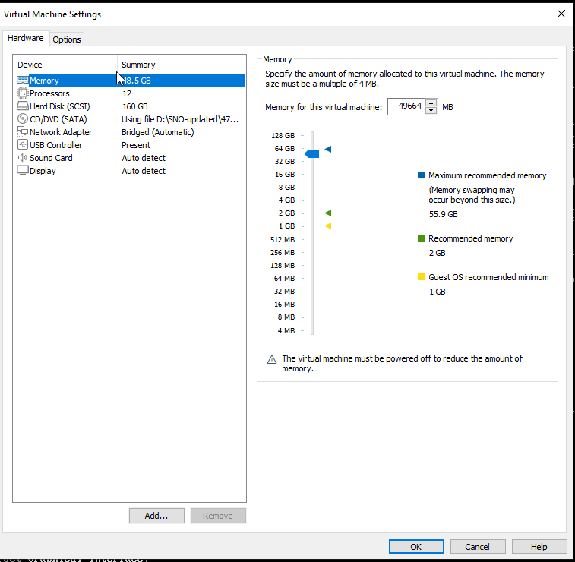

2.you can see the IP of this VM when Machine is Up

Do ssh

ssh [core@192.168.29.17](mailto:core@192.168.29.17)

4.sudo journalctl -u agent.service

5.ps -as | grep agent

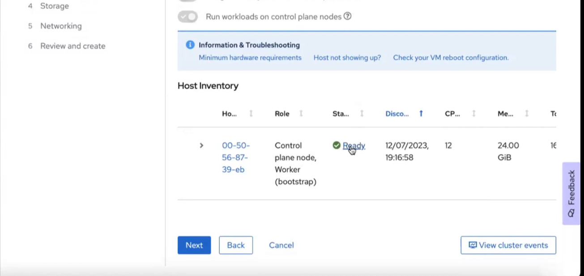

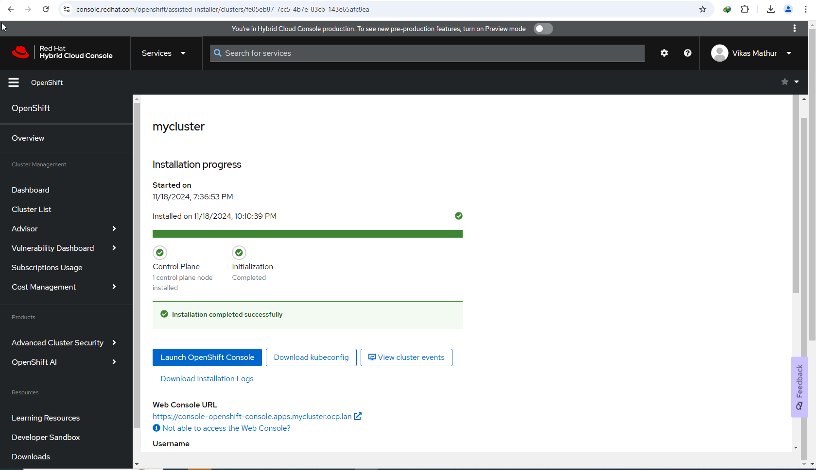

6.Lauch the OpenShift Dashboard

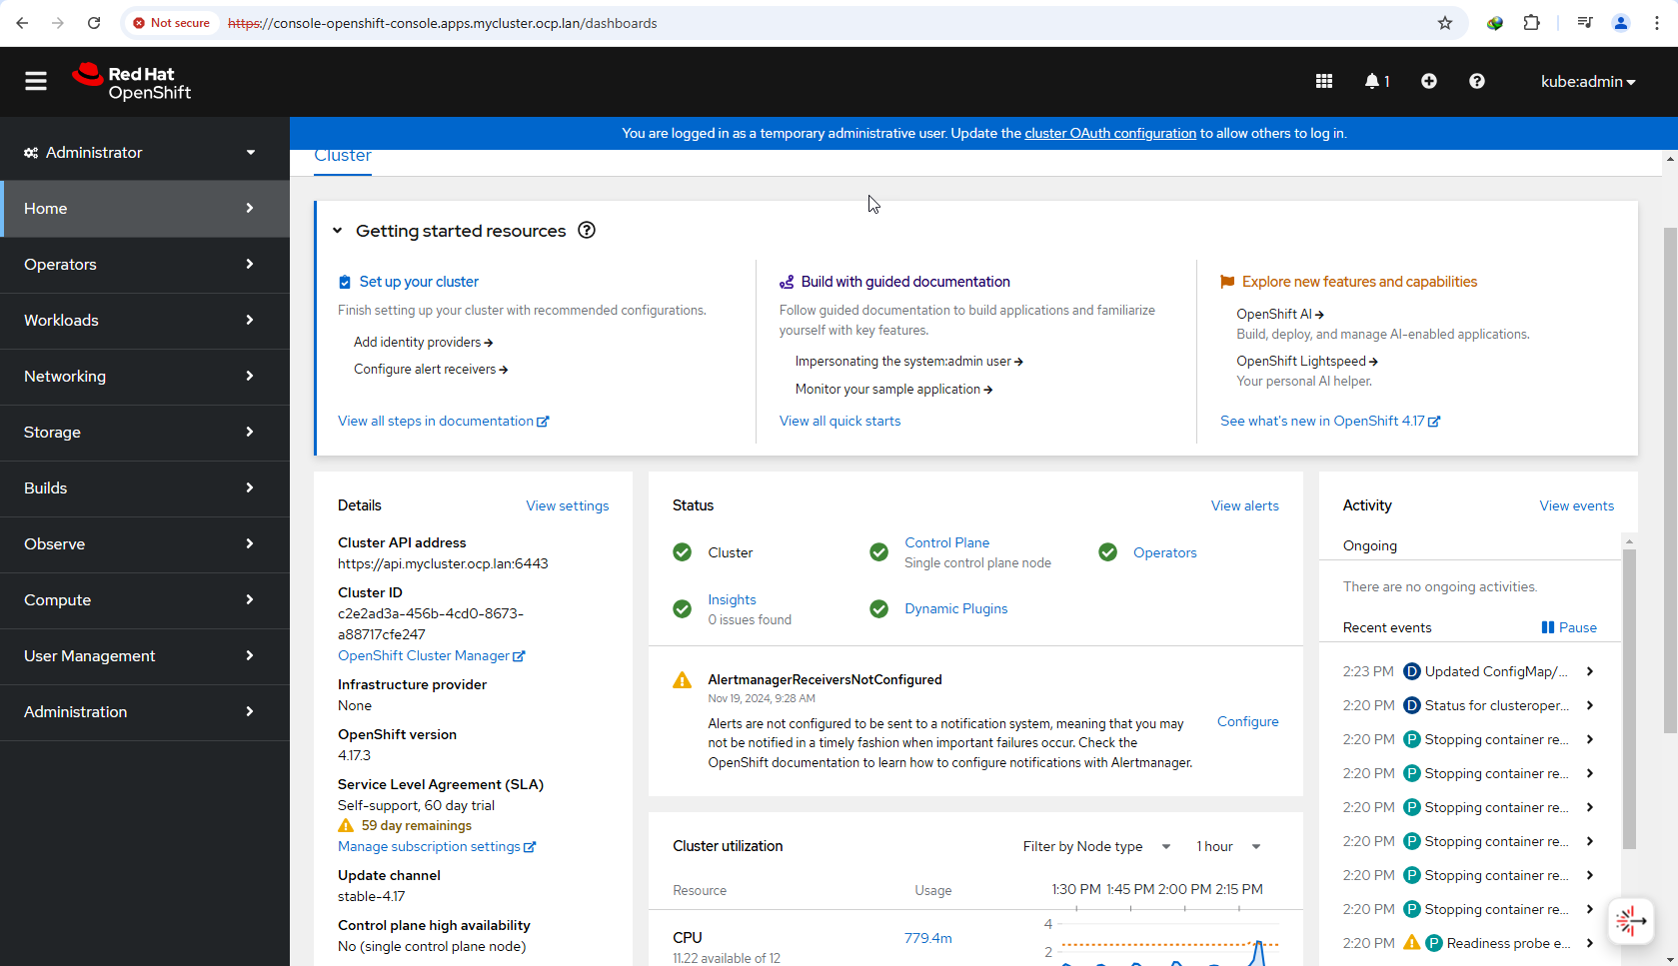

6.

